# Generic Ram Files

1. Simple RAM – Generic input size equals output size:  
   
2. Decoder – Generic selector size and output size:  
   
3. Generic RAM – Connects both:  
   

We have’t stimulate with it yet – but now we know that it it implemented the way that we want.

## RTL View: 8 bits input, 16 bits output

### Top RAM Generic:

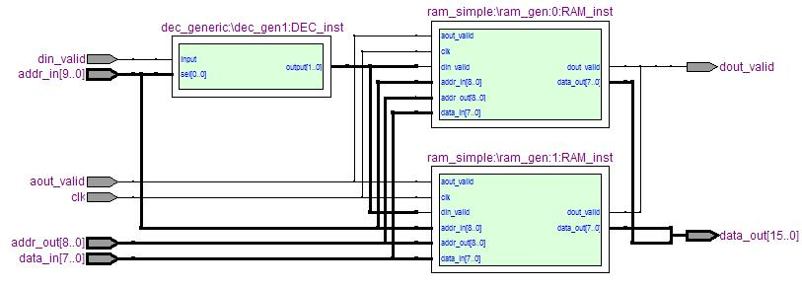

### Decoder:

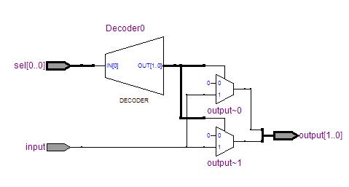

### Simple RAM:

